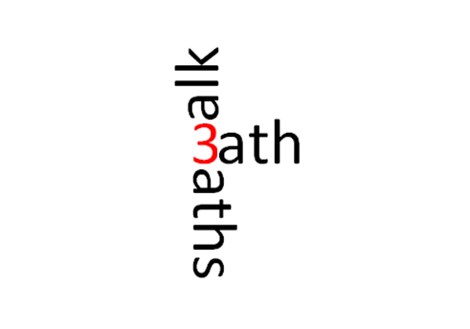

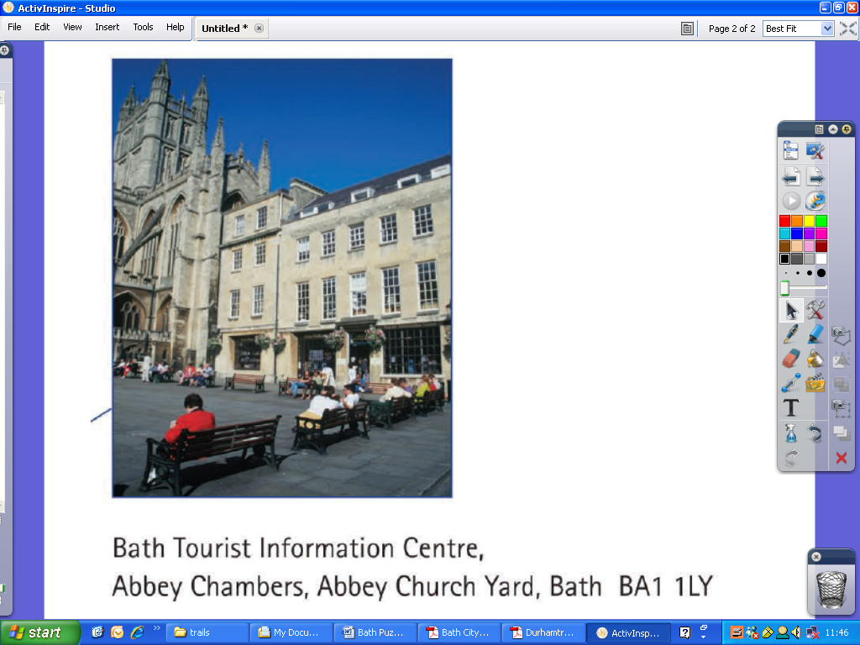

The trail begins in the Abbey Church Yard outside Tourist Information. See picture above for details, and see the back page for the map of the trail.

You must agree with the conditions of use at the bottom of this page before starting.

**Created with support from the following organisations and Dr Maths!**



The designers of this trail accept no responsibility for or liability from any claim, loss, injury or inconvenience caused as a result of following this Mathematics Trail. By taking part in the trail you agree to do so at your own risk.

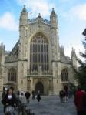1) **Bath Abbey**

How many years since King Edgar was crowned in the Abbey (see plaque on the back of the Abbey)

What percentages of the ladder steps are touched by the angels?

Name three different shapes you can find in the Abbey. For each of these shapes state two of their geometrical properties.

Describe the different kinds of symmetry you can see in the Abbey buildings? Draw an example in the box below.

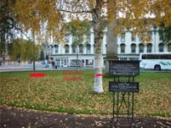2) **Orange Grove**

What shape is the grove?

How could you calculate the area of the Orange Grove? Spend a few minutes discussing how you could do this and then write down the method you would use in the box below.

If the entry to the Parade Gardens is 90p and you pay with at least one 5p, what is the fewest number of coins you could use to pay for your entry?

In the parade gardens is a statue of the fabled King Bladud who according to legend founded Bath. When you return to school or get home, try to find out who he visited and therefore why he is a mathematician?

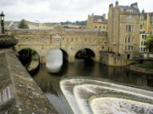3) **Pulteney Bridge** – Robert Adam’s bridge is one of only four bridges in the world to be lined with shops

What year was the bridge erected MDCCLXXIV – crack the code. Hint; (Plaque on the South West corner of the bridge)

How old is the bridge today? (correct to the nearest year)

What shape are the window panes? Write down the names of these shapes.

If the weather vane on top of the bridge is pointing due East and then turns 225 degrees clockwise, what direction is it now pointing?

Look down at the Weir;

What types of curves do the waterfalls resemble?

Can you draw a sketch of some below?

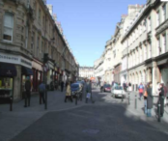4) **Milsom Street** was built in 1762 by Thomas Lightholder. The buildings were originally grand town houses, but most are now used as shops, offices and banks. They have 3 storeys with mansard roofs and Corinthian columns. The Octagon Chapel is on Milsom Street.

Estimate the length of Milson Street? Write down in the box below the method you used.

Is the street perpendicular or parallel to George street?

Find the shop Loch Fyne, what is the number written in Roman numerals?

During how many hours in the day are you required to pay for parking in Milsom Street?

Write down and add up all the numbers of the buses that you see as you walk down Milson Street? Are any of the bus numbers special?



(please take care when crossing Gay Street to find 5)

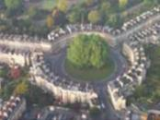5) **The Circus** – John Wood's inspiration was the Roman [Colosseum](http://en.wikipedia.org/wiki/Colosseum" \o "Colosseum), but whereas the [Colosseum](http://en.wikipedia.org/wiki/Colosseum" \o "Colosseum) was designed to be seen from the outside, the Circus faces inwardly.

How many trees are there?

What shape is the Circus?

What is the rotational symmetry of the Circus?

If there are on average 3 houses in each 20 degrees of the circle, how many houses are missing to complete the circle?

By drawing 6 straight lines between the 6 lampposts around the edge of the Circus make a hexagonal shape. What other shapes can you draw using 6 straight lines and the 6 lampposts? Maybe use the diagram below to help you.

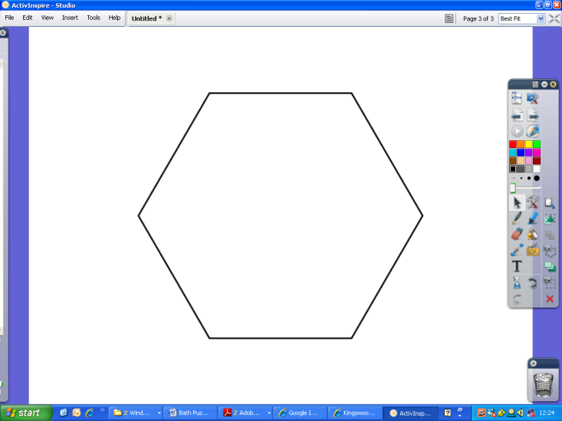

If the cost of a house in the Circus is £2,000,000 and you buy it with a 12% discount. How much does the Estate agent make if they get 2% of the sale price.

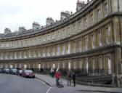6)**Royal Crescent** – Designed by the architect [John Wood the Younger](http://en.wikipedia.org/wiki/John_Wood_the_Younger) and built between 1767 and 1774, it is among the greatest examples of [Georgian architecture](http://en.wikipedia.org/wiki/Georgian_architecture) to be found in the [United Kingdom](http://en.wikipedia.org/wiki/United_Kingdom) – is that a Golden ratio windows I see?

Estimate the height of the Royal Crescent. Show your method.

How would you describe the shape of the Royal Crescent – use the Google Maps image below to help you

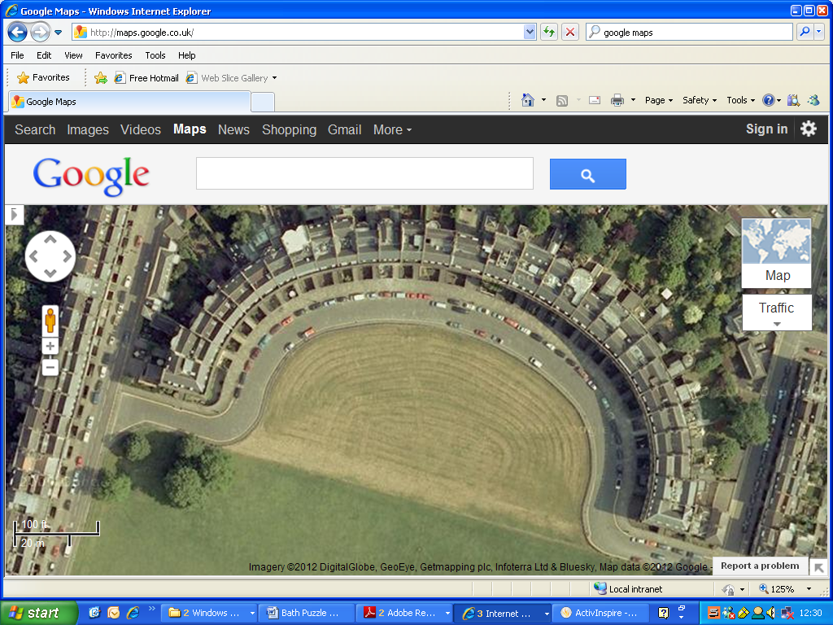

How would you estimate / calculate the area of the freshly mown lawn?

7) **Victoria Park**

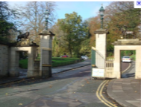

At the gate there are two lead plaques to Harry Patch who died aged 111 years.

How many Lions can you see?

Other things to spot are “Gold roses” How many more Lions would be needed to equal the number of Gold Roses?

What shape is the war memorial?

Behind the War memorial, what shapes can you see in the railings? Give two properties of these shapes.

Numbers on the War memorial

Find out the frequency of the numbers 1, 2, 3, and 4 on the memorial.

Use the numbers **1, 2, 3, and 4** to make the **biggest** number you can.

(Try adding, multiplying or combining.) Show your method in the box below.

What is the **smallest** number you can make with these four numbers?

Show your method in the box below.

Victoria Park has an 18 hole crazy golf course. If you take 4 shots for one-third of the holes, 3 shots for half the holes and 2 shots for the remaining holes, how many shots do you complete the course in?

(please take care when crossing Charlotte Street as you walk toward Queen Square)

8) Queen Square;

All of the buildings have been designated by [English Heritage](http://en.wikipedia.org/wiki/English_Heritage) as grade I [listed buildings](http://en.wikipedia.org/wiki/Listed_buildings). The obelisk in the centre of the square was erected by [Beau Nash](http://en.wikipedia.org/wiki/Beau_Nash) in 1738

Estimate the height of the obelisk in the box below.

Why not try one of these methods

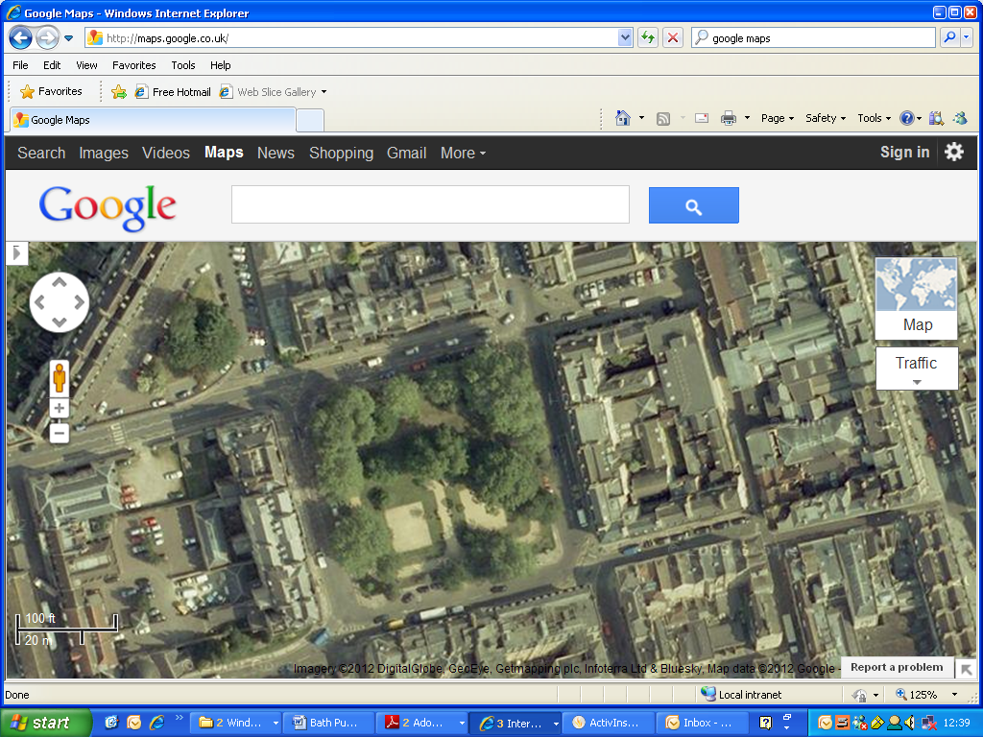

1. To measure something large maybe try to think about something smaller, such as a brick and think about how many bricks there are!
2. Stand in an appropriate spot in Queen Square, holding your pencil at arm’s length so that the pencil is the same size as the obelisk. Now try to think about how many “arm lengths” you will need to cover the distance from you to the base of the obelisk. Can you use this information to work out the size of the obelisk?
3. Can you make up your own?

Which letters on FRANCIS HOTEL have rotational symmetry? Write them below

(please take care when crossing Queen Square to find 9)

9) **Theatre Royal Bath**, is over 200 years old. It is one of the more important theatres in the United Kingdom outside London, with capacity for an audience of around 900.

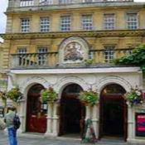

For a particular performance of a panto last year the average price of a seat is £35 and the capacity of the theatre was 840.

If the theatre is three quarters full, how much money has been taken by the theatre?

Given that the Theatre Royal does one performance a day and always sells out its 900 seats, how long was it open before its millionth customer watched a play?

Can you spot the things which break the vertical symmetry mirror line through the centre of the building. List them below

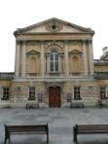10) **Pump Rooms and Roman Baths** - The first shrine at the site of the hot springs was built by [Celts](http://en.wikipedia.org/wiki/Celts), and was dedicated to the goddess [Sulis](http://en.wikipedia.org/wiki/Sulis" \o "Sulis), whom the [Romans](http://en.wikipedia.org/wiki/Roman_mythology) identified with [Minerva](http://en.wikipedia.org/wiki/Minerva).  The Roman temple was constructed in 60-70 AD and the bathing complex was gradually built up over the next 300 years.

How long have the Roman Baths been in Bath?

How many hours is it open for on Fridays?

In the box below draw a sketch to redesign the front of the building to make it symmetrical, aiming to make the smallest number of changes

If you walk around the corner to the Roman Baths shop, you will see some regular patterns using circular arcs in the cobbled paving. Each arc encloses a region of cobbled stones, about the same size, How many rows of stones are needed to form one of the circular patterns.

Using only the shapes you can see on the ground, draw a different symmetrical pattern in the box below.

**Challenge question:**

Using all the numbers in this trail document, what are the largest two prime factors?

_____________ & ____________ Subtract these. What is the answer? ________

Map of the Trail

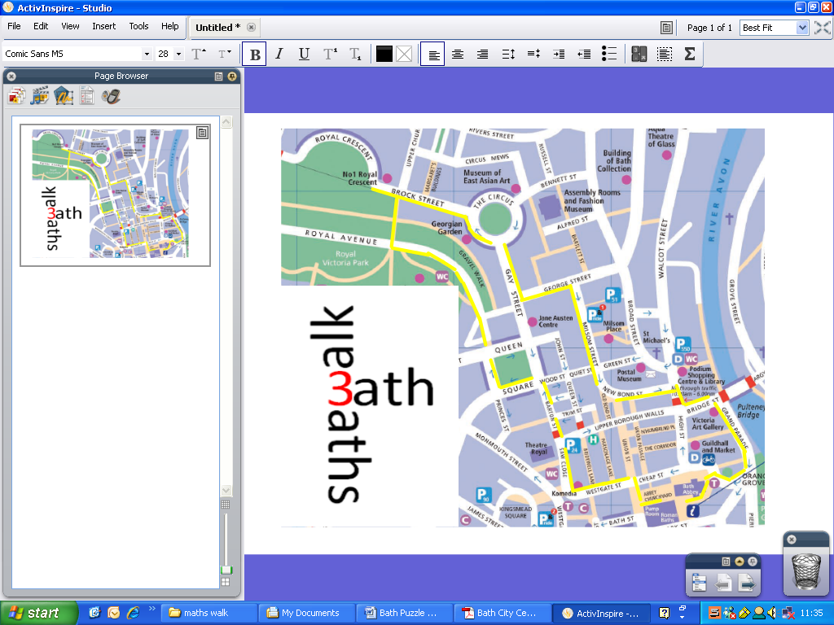

10

1

9

8

7

6

5

2

4

3

Each mathematical stop on the trail has a page inside the booklet for you to explore!

If you have any comments or further suggestions to add please contact the organisers using; [gjm@kingswood.bath.sch.uk](mailto:gjm@kingswood.bath.sch.uk)

Throughout this trail keep an eagle eye open for burglar alarm boxes. Put a tick inside the shape once you find it and draw any different shapes you find in the box provided